System Overview
The UPC-A barcode reader application is intended to assist data manipulation services by evaluating search terms as they are given on the different products, parsing the image and comparing them to the number of specialized dictionaries, and finally returning a number that specifies the information. Specific algorithms (provided by the developers).

.UPC-A barcode reader possesses easily recognizable user interface, and administration of the program is not much hard.

The software delivered in this iteration is fully functional in that it is capable of Decoding data from image files, parse image request, and produce a string of numbers that shows the information.

2.3 User Access Levels
No distinct user access levels are defined since under normal circumstances, UPC-A Barcode Reader activities should be completely transparent to its users.

GETTING STARTED

Extracting, Installing, and Running UPC-A Barcode Reader.

3.1 Extracting from the .ZIP archive
In addition to user documentation, the UPC-A Barcode Reader .ZIP file contains installers for the Windows service aspects of the application. Both must be executed before UPC-A Barcode Reader can be optimized and run.

3.2 Starting the Application
Install "MCR" Installer included in package, if posses any problem the latest update link is available in notepad file.
Just Click and run the "UPC-A Barcode Reader.exe"
Enter an image, and a methodology

Interface Information
Using Stored Image:
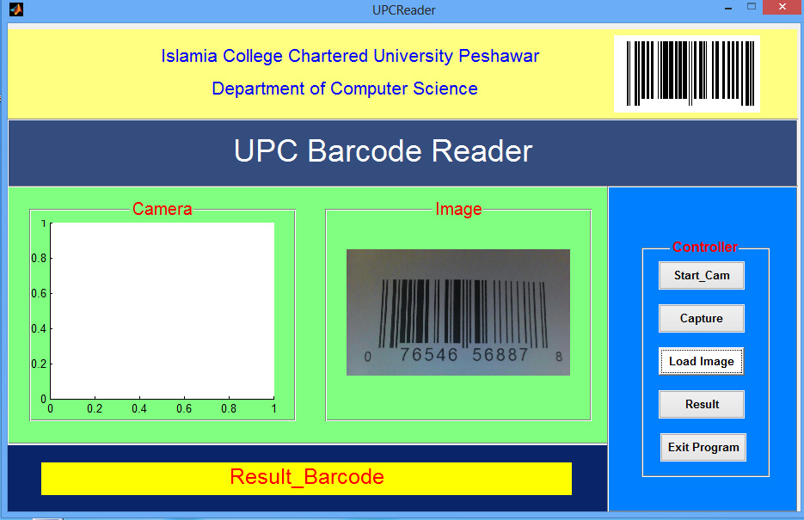

Step-1 By clicking the 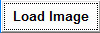 Button, File Explorer pop-ups The image is choosen from here, Then image is displayed in "Image" Panel
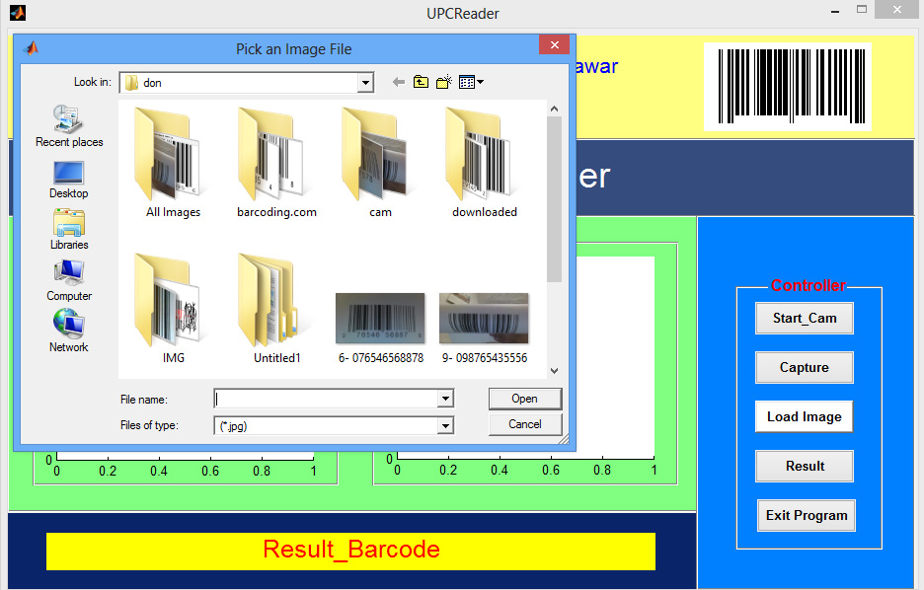
Step-2 By pressing the 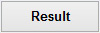 Button the Barcode is displayed down in form of string.
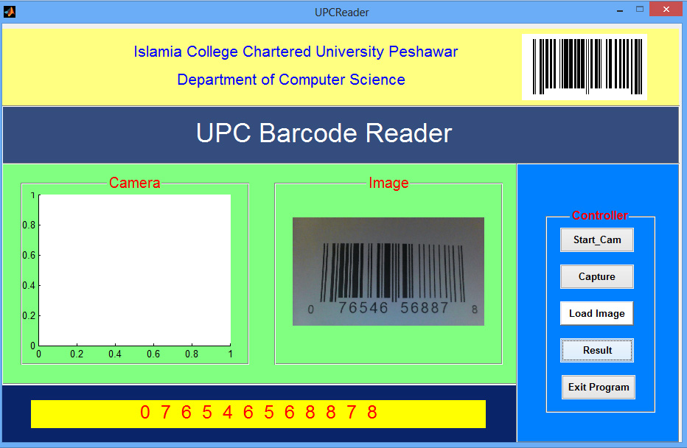

Using Cam for images
Step-1 By clicking the 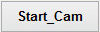Button, Web cam attached to computer starts. and video is displayed in the Camera Panel.
Step-2 Now Click 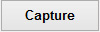Button, Image frame is captured and displayed in Image Panel, 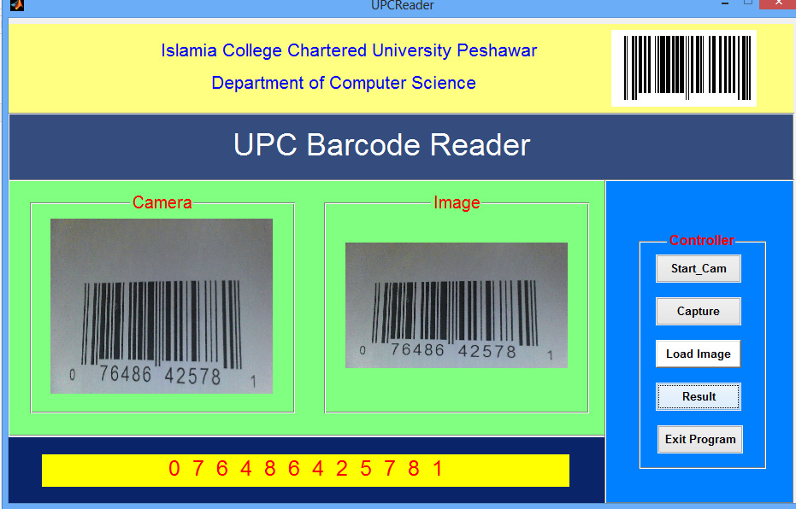
Step-3 Clicking Button the result is Displayed down on interface.

General Approach Information
Currently, the BinaryOnly and ClosestMatch methodologies are configured. Binary Only performs a simple binary search/match and identifies numbers in the dictionary (identical to Iteration 1 functionality). ClosestMatch will return all words.

Information
For additional information, Developer can be contacted at (philomni313@gmail.com).

